**PM ASSIGNMENT 02**

**M.BILAL AFZAL**

**19F-0126**

**6B**

**ALPHA ALGORITHM:**

**Q4:**

**L1= [⟨a, b, c⟩2, ⟨a, c⟩1, ⟨b, c, d⟩2]**

**L2:** **= [⟨a,c⟩2,⟨a,b,c⟩3,⟨a,b,b,c⟩2,⟨a,b,b,b,b,c⟩1]**

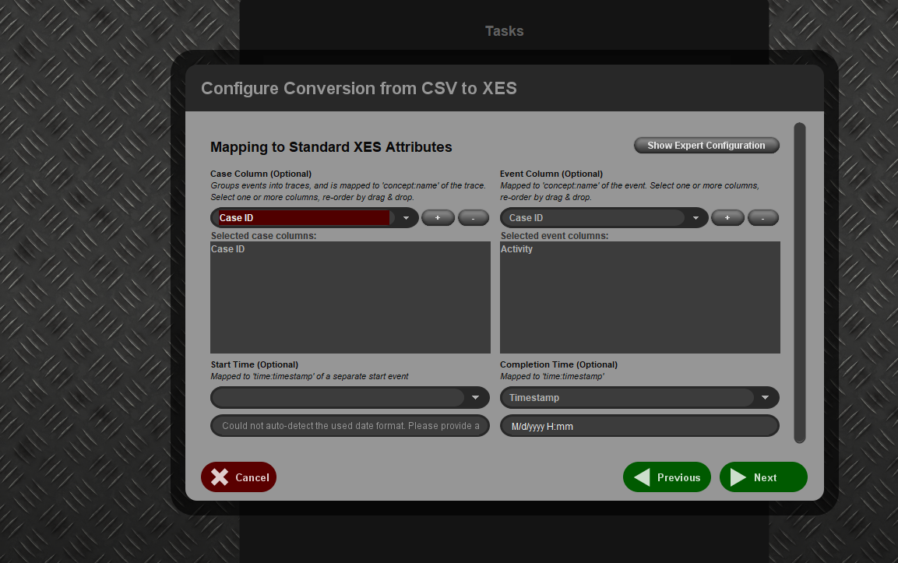

**Using Alpha:**

**Using Alpha+:**

**L3 = [⟨a, b, d⟩3, ⟨a, b, c, b, d⟩2, ⟨a, b, c, b, c, b, d⟩1]**

**Using alpha:**

**Using alpha+:**

**L4 = [⟨a,c,d⟩3,⟨b,c,e⟩2]**

